IOT Architecture and Protocols
(IOT505L)

Lab Observation Report





School of Engineering and Sciences (SEAS) Department of Electronics and Communication Engineering



IOT Architecture and Protocols LABORATORY MANUAL



Course Name | IOT Architecture and Protocols
Course Code | IOT505L
LIST OF EXPERIMENTS

S. No. | Name of the Experiment | Page No
1 | MQTT pub sub with mosquito broker | 1 - 3
2 | MQTT pub sub using arduino m5 stack | 4 - 6
3 | TCP server single client | 7 -12
4 | TCP server client using python and esp32 | 13 - 15
5 | TCP server multi-client | 16 - 20
6 | REST client server using arduino | 21 - 25
7 | Bluetooth Low Energy | 26 - 29
8 | Temperature sensing using iot and storing it in mysql using xampp | 30 - 34
9 | Connecting device to AWS | 35
10 | Connecting M5 stack to AWS | 36 - 38
11 | SNS AWS | 39
12 | Dynamo DB AWS | 40
13 | AWS lambda | 41
14 | CoAP client and server | 42 - 45
15 | UDP server and client | 46 - 49



IOT Architecture and Protocols

DO’S AND DON’TS

DO’S: -
- Students should carry observation notes and records completed in all aspects.
- The correct specifications of the equipment must be mentioned in the circuit diagram.
- Students should be aware of the operation of equipment.

- Students should take care of the laboratory equipment’s/ Instruments.
- After completing the connections, students should get the circuits verified by the LabInstructor.
- The readings/waveforms must be shown to the concerned faculty for verification.
- Students should ensure that all switches are in the OFF position to remove the connections leaving the laboratory.
- All patch cords and chairs should be placed properly in their respective positions.
DON’Ts: -
- Come late to the lab.
- Make or remove the connections with power ON.
- Switch ON the power supply without verification by the instructor.
- Switch OFF the machine with load.
- Leave the lab without the permission of the concerned faculty.

Experiment - 1

MQTT pub sub with mosquito broker

Aim: To write Python programs for MQTT publisher and subscriber and demonstrate the MQTT communication.
Apparatus: Python 3 Compiler
Paho MQTT library

Algorithm:

Publisher Algorithm:
  - Import the necessary MQTT client library (paho.mqtt.client) and the time library.
  - Define the on_message function to handle incoming messages.
  - Set the MQTT broker address to "test.mosquitto.org".
  - Create a new MQTT client instance named "P1".
  - Attach the on_message function to the client.
  - Connect to the MQTT broker.
  - Start the MQTT client loop.
  - Publish the message "OFF" to the topic "house/bulbs/bulb1".
  - Publish the message "ON" to the topic "house/bulbs/bulb1".
  - Wait for 10 seconds using time.sleep(10).
  - Stop the MQTT client loop.

Subscriber Algorithm:
  - Import the necessary MQTT client library (paho.mqtt.client) and the time library.
  - Define the on_message function to handle incoming messages.
  - Set the MQTT broker address to "test.mosquitto.org".
  - Create a new MQTT client instance named "P3".
  - Attach the on_message function to the client.
  - Connect to the MQTT broker.
  - Start the MQTT client loop.
  - Subscribe to the topic "house/bulbs/bulb1".
  - Wait for 100 seconds using time.sleep(100).
  - Stop the MQTT client loop.

Procedure:
- Run the subscriber python script first.
- It subscribes to the “house/bulbs/bulb1” topic and waits for 100 Seconds.
- Then run the publisher python script.
- When it publishes the values for the topic “house/bulbs/bulb1”, the subscriber script gets that message.
- Subscriber script prints the message received.

Program:

Publisher:
import paho.mqtt.client as mqtt #import the client1 import time
def on_message(client, userdata, message):
print("message received " ,str(message.payload.decode("utf-8"))) print("message topic=",message.topic)
print("message qos=",message.qos) print("message retain flag=",message.retain)
broker_address="test.mosquitto.org" print("creating new instance")
client = mqtt.Client("P1") #create new instance client.on_message=on_message #attach function to callback print("connecting to broker") client.connect(broker_address) #connect to broker client.loop_start() #start the loop
print("Publishing message to topic","house/bulbs/bulb1") client.publish("house/bulbs/bulb1","OFF") print("Publishing message to topic","house/bulbs/bulb1") client.publish("house/bulbs/bulb1","ON")
time.sleep(10) # wait #time.sleep(10) # client.loop_stop() #stop the loop

Subscriber:
import paho.mqtt.client as mqtt #import the client1 import time
def on_message(client, userdata, message):
print("message received " ,str(message.payload.decode("utf-8"))) print("message topic=",message.topic)
print("message qos=",message.qos) print("message retain flag=",message.retain)

broker_address="test.mosquitto.org" print("creating new instance")
client = mqtt.Client("P3") #create new instance client.on_message=on_message #attach function to callback print("connecting to broker") client.connect(broker_address) #connect to broker client.loop_start() #start the loop
print("Subscribing to topic","house/bulbs/bulb1") client.subscribe("house/bulbs/bulb1") time.sleep(100) # wait
client.loop_stop() #stop the loop

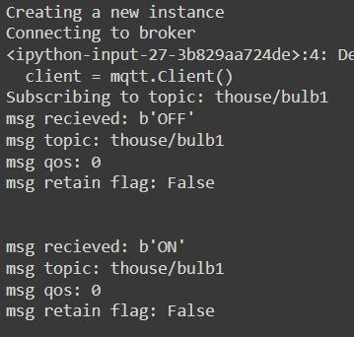
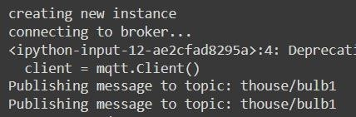
Output:

Conclusion: Thus, python programs are written and the MQTT communication is demonstrated using a broker.

Experiment – 2

MQTT pub sub using arduino m5 stack

Aim: To demonstrate MQTT Publish Subscribe using M5 Stack and Web site.

Apparatus:
  - Arduino
  - MS Stack board
  - Test Client website

Algorithm
- Include Pub Sub Client and Wifi modules.
- Allot wifi name and password so that it can connect to wifi
- In setup, setup wifi, setup the server and setup the callback.
- In the loop, if client not connected, reconnect If connected, Publish message and print it. In setup Wifi, connect wifi using credentials, if not connected print ".".
- In callback function, print, the message.
- To reconnect, use reconnect function if failed, try again in 5 seconds

Procedure
- Open Arduino and dump the MQTT program into M5 Stack board.
- Run the test client website using, the topic type and broker used in the MQTT Arduino.
- Enter a message in test client and observe output in MS. Stack.

Code
#include <PubSubClient.h> #include <WiFi.h> #include "M5Stack.h"

WiFiClient espClient; PubSubClient client(espClient);

const char* ssid = "Na wifi"; const char* password = "sarala999";
const char* mqtt_server = "test.mosquitto.org";

unsigned long lastMsg = 0;
#define MSG_BUFFER_SIZE (50) char msg[MSG_BUFFER_SIZE]; int value = 0;

void setupWifi();
void callback(char* topic, byte* payload, unsigned int length); void reConnect();

void setup() { M5.begin(); M5.Power.begin(); setupWifi();
client.setServer(mqtt_server, 1883); client.setCallback(callback);
}

void loop() {
if (!client.connected()) { reConnect();
}
client.loop();

unsigned long now = millis(); if (now - lastMsg > 2000) {
lastMsg = now;
++value;
snprintf(msg, MSG_BUFFER_SIZE, "hello world #%ld", value); M5.Lcd.print("Publish message: ");
M5.Lcd.println(msg); client.publish("M5Stack", msg); if (value % 12 == 0)

{
M5.Lcd.clear(); M5.Lcd.setCursor(0, 0);
}
}
}

void setupWifi() { delay(10);
M5.Lcd.printf("Connecting to %s", ssid); WiFi.mode(WIFI_STA); WiFi.begin(ssid, password);

while (WiFi.status() != WL_CONNECTED) { delay(500);
M5.Lcd.print(".");
}
M5.Lcd.printf("\nSuccess\n");
}

void callback(char* topic, byte* payload, unsigned int length) { M5.Lcd.print("Message arrived [");
M5.Lcd.print(topic); M5.Lcd.print("] ");
for (int i = 0; i < length; i++) { M5.Lcd.print((char)payload[i]);
}
M5.Lcd.println();
}

void reConnect() {
while (!client.connected()) { M5.Lcd.print("Attempting MQTT connection..."); String clientId = "M5Stack-";
clientId += String(random(0xffff), HEX); if (client.connect(clientId.c_str())) {
M5.Lcd.printf("\nSuccess\n"); client.subscribe("M5Stack");
} else {
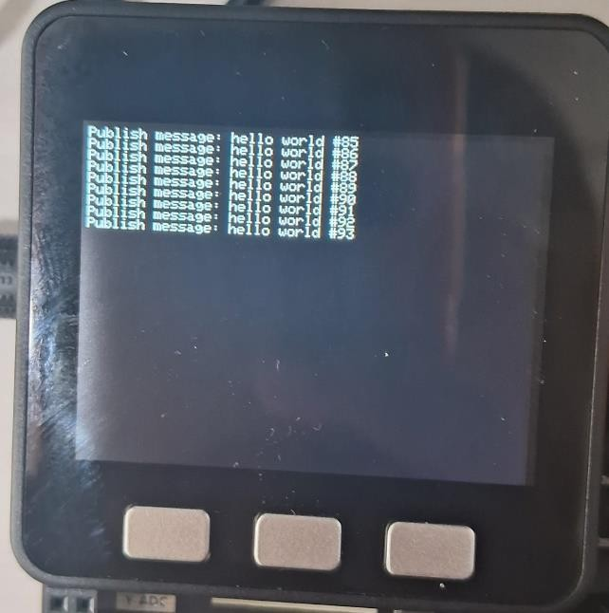
M5.Lcd.print("failed, rc="); M5.Lcd.print(client.state()); M5.Lcd.println("try again in 5 seconds"); delay(5000);
}
}
}

Output:

Conclusion: Hence we demonstrated MQTT Publish Subscribe using M5 Stack and Web site.

Experiment – 3

TCP server single client
Aim: To verify TCP Server - Single Client Socket Program

Apparatus:
Linux terminal

Algorithm:

TCP Server:
- Using socket (), Create TCP Socket
- Using bind(), Bind the socket to Server address.
- Using listen(), put the server socket in a passive mode, where it wait for the client to approach the server to make a connection.
- Using accept(), At this point, connection is established between client and server, and they are ready to transfer data.
- After the communication is done ,go back to step 3

TCP Client:
- Create TCP socket.
- Connect newly created client socket to server.
- Send/receive data from server.

Procedure:
- Open Linux terminal
- Install GCC compiler
- Compile client and server files.
- Run the server in one terminal.
- Run client in another terminal
- Communicate between client and Server..
- Disconnect the connection.
Flow Chart:
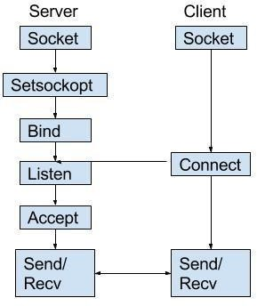

Program:
TCP Server: #include <netdb.h> #include <stdio.h> #include <stdlib.h> #include <string.h>
#include <sys/socket.h> #include <netinet/in.h> #include <arpa/inet.h> #include "unistd.h" #define MAX 80
#define PORT 10000 #define SA struct sockaddr void func(int sockfd)
{
char buff[MAX]; int n;
for (;;) {
// Nullify the buffer bzero(buff, sizeof(buff)); printf("Enter the string : "); n = 0;
while ((buff[n++] = getchar()) != '\n');
write(sockfd, buff, sizeof(buff)); bzero(buff, sizeof(buff)); read(sockfd, buff, sizeof(buff)); printf("From Server : %s", buff);
if ((strncmp(buff, "exit", 4)) == 0) {
printf("Client Exit...\n"); break;
}
}
}

int main()
{
int sockfd, connfd;
struct sockaddr_in servaddr, cli;
// socket create and verification
sockfd = socket(AF_INET, SOCK_STREAM, 0); if (sockfd == -1) {
printf("socket creation failed...\n"); exit(0);
}
else
printf ("Socket successfully created..\n"); bzero(&servaddr, sizeof(servaddr));
// assign IP, PORT servaddr.sin_family = AF_INET;
servaddr.sin_addr.s_addr = inet_addr("127.0.0.1"); // loopback address servaddr.sin_port = htons(PORT);
// connect the client socket to server socket
if (connect(sockfd, (SA*)&servaddr, sizeof(servaddr)) != 0) { printf("connection with the server failed...\n"); exit(0);
}
else
printf("connected to the server..\n");
// function for chat func(sockfd);
// close the socket close(sockfd);
}

TCP Client: #include <netdb.h> #include <stdio.h> #include <stdlib.h> #include <string.h>
#include <sys/socket.h> #define MAX 80
#define PORT 8080 #define SA struct sockaddr void func(int sockfd)
{

char buff[MAX]; int n;
for (;;) {
bzero(buff, sizeof(buff)); printf("Enter the string : "); n = 0;
while ((buff[n++] = getchar()) != '\n') ;

write(sockfd, buff, sizeof(buff)); bzero(buff, sizeof(buff)); read(sockfd, buff, sizeof(buff)); printf("From Server : %s", buff);
if ((strncmp(buff, "exit", 4)) == 0) {
printf("Client Exit...\n"); break;
}
}
}

int main()
{
int sockfd, connfd;
struct sockaddr_in servaddr, cli;
// socket create and verification
sockfd = socket(AF_INET, SOCK_STREAM, 0); if (sockfd == -1) {
printf("socket creation failed...\n"); exit(0);
}
else
printf("Socket successfully created..\n"); bzero(&servaddr, sizeof(servaddr));
// assign IP, PORT servaddr.sin_family = AF_INET;
servaddr.sin_addr.s_addr = inet_addr("127.0.0.1");
servaddr.sin_port = htons(PORT);

// connect the client socket to server socket
if (connect(sockfd, (SA*)&servaddr, sizeof(servaddr)) != 0) { printf("connection with the server failed...\n");
exit(0);
}
else
printf("connected to the server..\n");
// function for chat func(sockfd);
// close the socket close(sockfd);
}

Output:

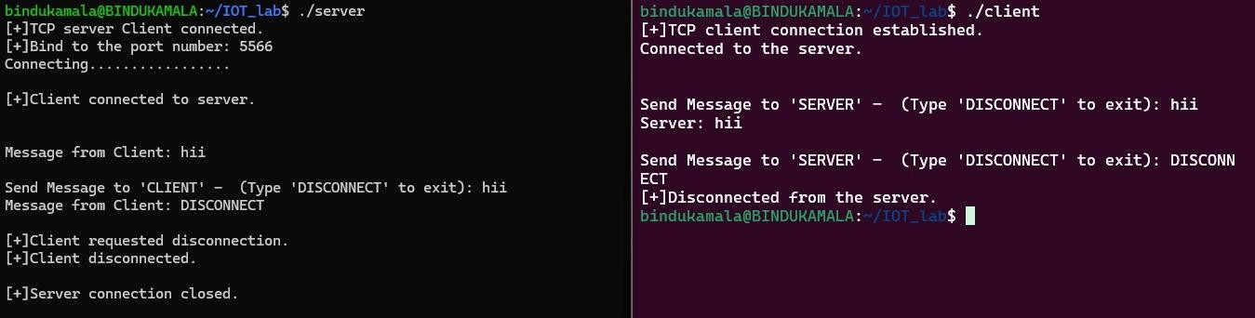

Conclusion: Hence verified TCP Server - Single Client Socket Program

Experiment – 4

TCP server client using python and esp32
Aim: To create TCP Server - Client using python and ESP32 (M5 Stack)

Apparatus:
- M5 stack kit
- Spyder environment

Algorithm:

TCP Server:
  - Create a Socket
- Bind the Socket
- Start listening through the Socket
- Accept the Connection
- Receive and send the data.
- Close the connection.
TCP Client –
- Use Wi-Fi Credentials to connect to Wi-Fi
- Connect to the host
- Receive and print data
- Close the Connection.

Procedure:
- Use M5 Stack board as client
- For this, dump the code using Arduino.
- Use same port and host IP address
- Connect both server and client devices to same network.
- Turn off all the firewalls.
- Run the server program first and then the client program.
- Observe the output.

Code
#include <WiFi.h>

// Replace with your network credentials const char* ssid = "YOUR_SSID";
const char* password = "YOUR_PASSWORD";

// Replace with the IP address of the server IPAddress server_address(192, 168, 1, 100);

void setup() { Serial.begin(115200); delay(10);

// Connect to WiFi WiFi.begin(ssid, password);
while (WiFi.status() != WL_CONNECTED) { delay(500);
Serial.print(".");
}
Serial.println(""); Serial.println("WiFi connected");

// Connect to the server WiFiClient client;
if (!client.connect(server_address, 10000)) { Serial.println("connection failed");
return;
}

// Send some data
String data = "Hello from ESP32!"; client.println(data);

// Receive the response
String response = client.readStringUntil('\r'); Serial.println(response);

// Close the connection client.stop();
}

void loop() {
// Do nothing
}

Output:

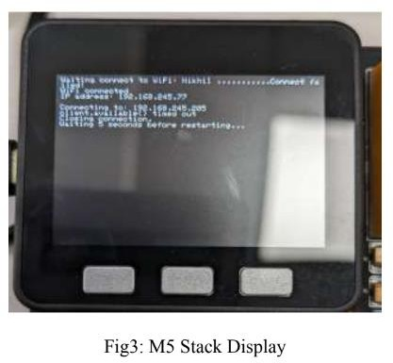

Conclusion:
Hence created TCP Server - Client using python and ESP32 (M5 Stack).

Experiment – 5

TCP server multi-client
Aim: Write a C program for Tcp server multi-client socket program
Compiler: Linux

Algorithm:
TCP Server:
- TCP Server uses fork which creates a new replica of server whenever a new client is connected.
- If the fork returns zero, it is child process
- If the fork returns child process id it is a parent process
- TCP Server creates a socket
- Bind the Socket
- Starts listing and creates. a child process whenever new client is connected
- Send and receives data
- Close the connection

TCP client:
- It creates the socket.
- Connects with the Server
- Starts Communications, sends & receives data.
- Close the Connections

Procedure:
- Open Linux terminal
- Install GCC compiler.
- Compile client and server files.
- Run the server in one terminal.
- Run clients in other terminals.
- Communicate between clients and Server.
- Disconnect the connection.

Program:

Server Program

#include <stdio.h> #include <stdlib.h> #include <string.h> #include <unistd.h> #include <sys/socket.h> #include <netinet/in.h> #include <arpa/inet.h> #include <pthread.h>

#define PORT 4444
#define MAX_CLIENTS 5

void *handle_client(void *arg) { int clientSocket = *((int *)arg); free(arg);
char buffer[1024];

while (recv(clientSocket, buffer, sizeof(buffer), 0) > 0) { if (strcmp(buffer, ":exit") == 0) {
close(clientSocket);

printf("[-]Client disconnected.\n"); pthread_exit(NULL);
}

}
printf("Client: %s\n", buffer); send(clientSocket, buffer, strlen(buffer), 0);
}

close(clientSocket); pthread_exit(NULL);

int main() {

int sockfd, clientSocket;

struct sockaddr_in serverAddr, clientAddr; socklen_t addr_size = sizeof(clientAddr);
sockfd = socket(AF_INET, SOCK_STREAM, 0); memset(&serverAddr, 0, sizeof(serverAddr)); serverAddr.sin_family = AF_INET; serverAddr.sin_port = htons(PORT); serverAddr.sin_addr.s_addr = INADDR_ANY;
bind(sockfd, (struct sockaddr *)&serverAddr, sizeof(serverAddr));

listen(sockfd, MAX_CLIENTS); printf("[+]Server is listening...\n");

while (1) {
clientSocket = accept(sockfd, (struct sockaddr *)&clientAddr, &addr_size); printf("Connection accepted from %s:%d\n", inet_ntoa(clientAddr.sin_addr),
ntohs(clientAddr.sin_port)); pthread_t tid;
int *new_client = malloc(sizeof(int));

*new_client = clientSocket;

pthread_create(&tid, NULL, handle_client, (void *)new_client);

}

close(sockfd); return 0;
}

Client Code:

#include <stdio.h> #include <stdlib.h> #include <string.h> #include <unistd.h> #include <sys/socket.h> #include <netinet/in.h> #include <pthread.h> #include <arpa/inet.h>

#define PORT 4444 int main() {
int clientSocket;

struct sockaddr_in serverAddr; char buffer[1024];
clientSocket = socket(AF_INET, SOCK_STREAM, 0);

memset(&serverAddr, 0, sizeof(serverAddr)); serverAddr.sin_family = AF_INET; serverAddr.sin_port = htons(PORT); serverAddr.sin_addr.s_addr = inet_addr("127.0.0.1");
connect(clientSocket, (struct sockaddr *)&serverAddr, sizeof(serverAddr)); printf("[+]Connected to Server.\n");
while (1) { printf("Client: ");
fgets(buffer, sizeof(buffer), stdin);
buffer[strcspn(buffer, "\n")] = '\0'; // Remove trailing newline

memset(buffer, 0, sizeof(buffer)); recv(clientSocket, buffer, sizeof(buffer), 0); printf("Server: %s\n", buffer);
send(clientSocket, buffer, strlen(buffer), 0); if (strcmp(buffer, ":exit") == 0) {
close(clientSocket);
printf("[-]Disconnected from server.\n"); exit(EXIT_SUCCESS);
}
}

return 0;

}

Output:
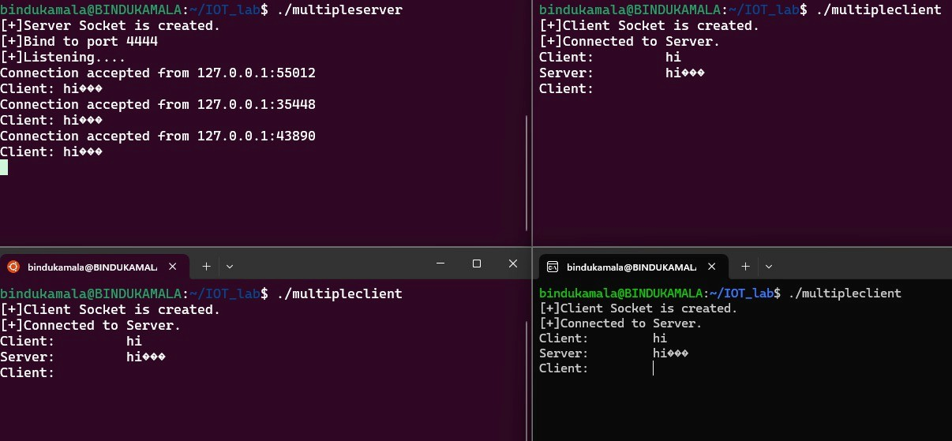

Conclusion: Hence written a C program for TCP server multi-client socket program

Experiment – 06

REST client server using Arduino

Aim: To demonstrate rest server using M5 stack in Arduino and web client

Apparatus:
- Rest client extension.

- M5 stack kit

- Arduino

Algorithm:

1. Import necessary libraries like WiFi.h for ESP32 WiFi chip and aREST library.
- Define WiFi network parameters like SSID and password.
- Create an instance of the aREST library.
- Declare variables (temperature and humidity) to be exposed to the API.
- Declare functions (ledControl) to be exposed to the API.
- In the setup function, initialize serial communication.
- Initialize variables and expose them to the REST API.
- Define the name and ID for the device.
- Connect to the WiFi network.
- Start the server.
- Print the IP address.
- In the loop function.
- Handle REST calls:
- Check for client connections.
- Handle REST requests if any.
- Define a custom function (led Control) accessible by the API to control an LED.
- Implement logic to handle REST API calls and respond accordingly.
- Establish communication between the client (REST API) and the server (ESP32) to exchange data and control signals.

Procedure
- Open the Arduino IDE.
- Write or paste the provided code into a new sketch.
- Make sure the necessary libraries (WiFi.h and aREST) are installed. If not, install them using the Arduino library Manager.
- Set up the WiFi network parameters by replacing "Na wifi" and "sarala999" with your WiFi network SSID and password.
- Define variables (temperature and humidity) and functions (ledControl) to be exposed to the API as per the provided code.
- Upload the sketch to your ESP32 board.
- Install the REST API Chrome extension on your Chrome browser if not already installed.
8. Use the REST API extension to interact with your ESP32 board by sending GET and POST
requests to control.
Code
/*
This is a simple example of the aREST Library for the ESP32 Wi-Fi chip. See the README file for more details.
Written in 2017 by Marco Schwartz under a GPL license.

*/

// Import required libraries #include <WiFi.h> #include <aREST.h>
// Create aREST instance aREST rest = aREST();
// WiFi parameters

const char* ssid = "Na wifi";

const char* password = "sarala999";

// Create an instance of the server WiFiServer server(80);

// Variables to be exposed to the API int temperature;
int humidity;

// Declare functions to be exposed to the API int ledControl(String command);
void setup()

{

// Start Serial
Serial.begin(115200);

// Init variables and expose them to REST API temperature = 24;
humidity = 40; rest.variable("temperature",&temperature);
rest.variable("humidity",&humidity);
// Function to be exposed rest.function("led",ledControl);
// Give name & ID to the device (ID should be 6 characters long) rest.set_id("1");
rest.set_name("esp32");

// Connect to WiFi WiFi.begin(ssid, password);
while (WiFi.status() != WL_CONNECTED) { delay(500);
Serial.print(".");
}

Serial.println("");

Serial.println("WiFi connected");

// Start the server server.begin(); Serial.println("Server started");
// Print the IP address Serial.println(WiFi.localIP());
}

void loop() {

// Handle REST calls

WiFiClient client = server.available(); if (!client) {
return;

}

while(!client.available()){ delay(1);
}

rest.handle(client);

}

// Custom function accessible by the API int ledControl(String command) {
// Get state from command int state = command.toInt(); digitalWrite(6,state);
return 1;

}

Output:
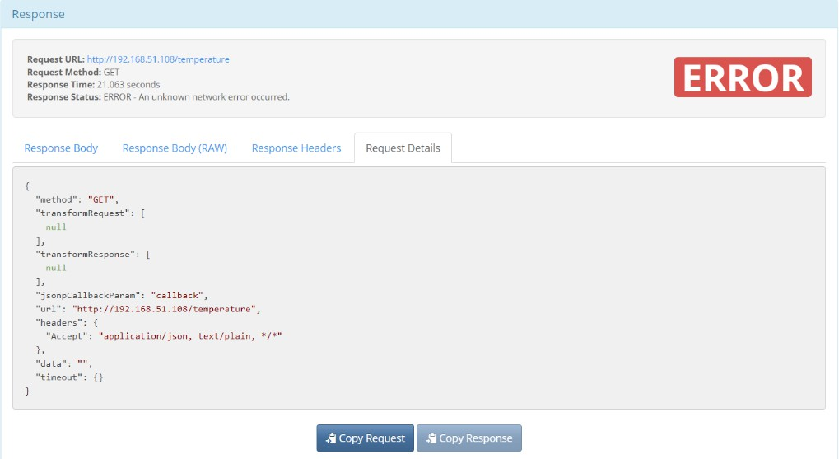

Conclusion - Hence we observed the Rest client server using Arduino M5 Stack and web client.

Experiment – 7

Bluetooth Low Energy

Aim: To implement Bluetooth low energy
Apparatus: 1) M5 stack
  - Arduino
  - nRF connect app

Algorithm:

Initialization and Setup:
- Initialize serial communication for debugging.
- Create a BLE device with the name “ESP32”.
- Create a BLE server.
- Define a service with the UUID “4fafc201-1fb5-459e-8fcc-c5c9c331914b”.
- Create a characteristic with the UUID “beb5483e-36e1-4688-b7f5-ea07361b26a8”.
- This characteristic supports read, write, notify, and indicate properties.
- Add a BLE descriptor to the characteristic.

Main Loop:
- If a device is connected, set the value of the characteristic and notify the client.
- Increment the value and introduce a delay to avoid Bluetooth stack congestion.
- If the device is disconnected, restart advertising.
- When a new connection is established, additional actions can be performed.

UUIDs:
- The UUIDs are unique identifiers for the service and characteristic. Descriptor:
- The BLE2902 descriptor configures notifications and indications for the characteristic. Advertising:
- Advertise the service UUID.
- Set the minimum preferred value to 0x00 to avoid advertising this parameter.

Procedure:
- Dump the program into M5 Stack board.
- Scan devices using nRF connect mobile app.
- Connect to your device using ID name.
- Observe the characteristics and values sent the board.

Flow Chart:

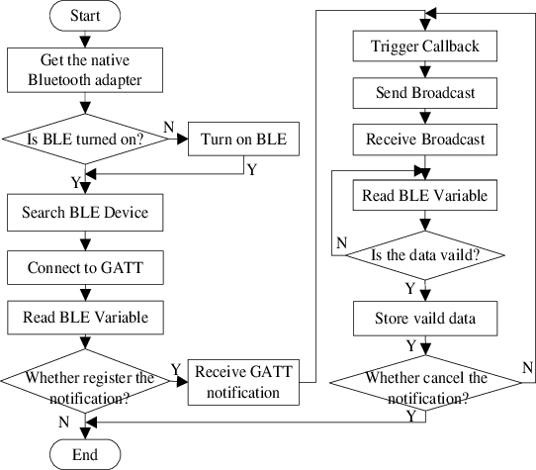
Program:

#include <BLEDevice.h> #include <BLEServer.h> #include <BLEUtils.h> #include <BLE2902.h>

BLEServer* pServer = NULL; BLECharacteristic* pCharacteristic = NULL; bool deviceConnected = false;
bool oldDeviceConnected = false; uint32_t value = 0;

// See the following for generating UUIDs:
// https://www.uuidgenerator.net/

#define SERVICE_UUID "4fafc201-1fb5-459e-8fcc-c5c9c331914b"
#define CHARACTERISTIC_UUID "beb5483e-36e1-4688-b7f5-ea07361b26a8"

class MyServerCallbacks: public BLEServerCallbacks { void onConnect(BLEServer* pServer) { deviceConnected = true;
};

void onDisconnect(BLEServer* pServer) { deviceConnected = false;

}
};
void setup() { Serial.begin(115200);
// Create the BLE Device BLEDevice::init("ESP32");
// Create the BLE Server
pServer = BLEDevice::createServer();
pServer->setCallbacks(new MyServerCallbacks());
// Create the BLE Service
BLEService *pService = pServer->createService(SERVICE_UUID);

// Create a BLE Characteristic
pCharacteristic = pService->createCharacteristic( CHARACTERISTIC_UUID,
BLECharacteristic::PROPERTY_READ | BLECharacteristic::PROPERTY_WRITE | BLECharacteristic::PROPERTY_NOTIFY | BLECharacteristic::PROPERTY_INDICATE
);

// https://www.bluetooth.com/specifications/gatt/viewer?attributeXmlFile=org.bluetooth.descriptor.gatt.client
_characteristic_configuration.xml
// Create a BLE Descriptor
pCharacteristic->addDescriptor(new BLE2902());

// Start the service pService->start();

// Start advertising
BLEAdvertising *pAdvertising = BLEDevice::getAdvertising(); pAdvertising->addServiceUUID(SERVICE_UUID); pAdvertising->setScanResponse(false);
pAdvertising->setMinPreferred(0x0); // set value to 0x00 to not advertise this parameter BLEDevice::startAdvertising();
Serial.println("Waiting a client connection to notify...");
}

void loop() {
// notify changed value if (deviceConnected) {
pCharacteristic->setValue((uint8_t*)&value, 4); pCharacteristic->notify();
value++;
delay(3); // bluetooth stack will go into congestion, if too many packets are sent, in 6 hours test i was able to go as low as 3ms
}

// disconnecting
if (!deviceConnected && oldDeviceConnected) {
delay(500); // give the bluetooth stack the chance to get things ready pServer->startAdvertising(); // restart advertising Serial.println("start advertising");
oldDeviceConnected = deviceConnected;
}
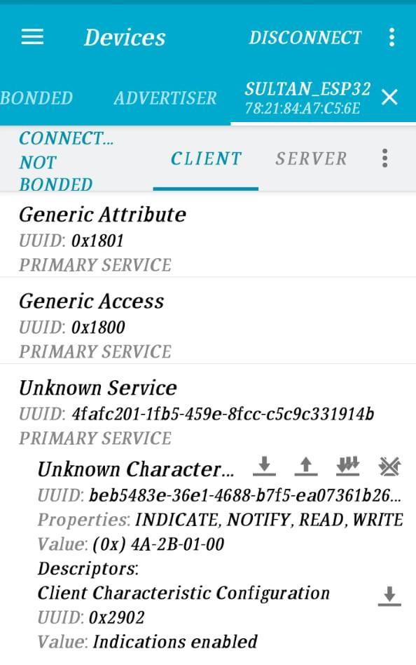
// connecting
if (deviceConnected && !oldDeviceConnected) {
// do stuff here on connecting oldDeviceConnected = deviceConnected;
}
}

Output:

Conclusion: Hence we implement Bluetooth low energy.

Experiment – 8

Temperature sensing using iot and storing it in mysql using xampp

Aim:
To detect the temperature of a room using iot and storing it in mysql using xampp

Apparatus:-
- M5 Stack Board
- Arduino
- PHP program.
- XAMPP

Algorithm:

Arduino code:
- Include all the necessary libraries.
- Initialize serial begin time and delay for setup.
- Setup Wi-Fi connection using Wi-Fi SSID name & the password.
- In void loop, use http begin by giving System's IP address.
- Send the data using POST method.
- If the response is greater than zero send the data using get string.
- Else print that POST failed.
- End the http program.

PHP Code:
- Take data from Post action in which the server is self.
- Take the temperature as input through submit.
- Connect to MySQL using server name, username and dB name.
- If connection is not established, print connection failed.
- If connection established, get the data using REQUEST from POST.
- If no value entered, print temperature is empty.
- Or insert the value into MySQL.
- If the value entered successfully, print. new record created successfully.
- Else print error.
- Close the connection with MySQL.

Procedure:
- Open XAMPP and start MySQL and Apache server.
- Dump the Arduino code into M5 Stack board.
- Run the PHP code.
- Create a database in MySQL with parameters datetime and temperature.
- After successful sending of data, check in the database whether the new record is created or not.

Code:
Source CODE:

#include <Arduino.h>

#include <WiFi.h> #include <WiFiMulti.h>

#include <HTTPClient.h> #define USE_SERIAL Serial WiFiMulti wifiMulti;

void setup() { USE_SERIAL.begin(115200);
USE_SERIAL.println(); USE_SERIAL.println(); USE_SERIAL.println();

for(uint8_t t = 4; t > 0; t--) { USE_SERIAL.printf("[SETUP] WAIT %d...\n", t);
USE_SERIAL.flush(); delay(1000);
}

wifiMulti.addAP("oneplus", "12345678");

}

void loop() {
// wait for WiFi connection if((wifiMulti.run() == WL_CONNECTED)) {
HTTPClient http; USE_SERIAL.print("[HTTP] begin...\n");
// configure traged server and url
//http.begin("https://www.howsmyssl.com/a/check", ca); //HTTPS http.begin("http://192.168.138.113/index.php"); //HTTP

USE_SERIAL.print("[HTTP] POST...\n");
// start connection and send HTTP header
//int httpCode = http.GET();

// Specify content-type header
http.addHeader("Content-Type", "application/x-www-form-urlencoded");
// Data to send with HTTP POST
String httpRequestData = "fname=24.5";
// Send HTTP POST request
int httpResponseCode = http.POST(httpRequestData);

// If you need an HTTP request with a content type: application/json, use the following:
//http.addHeader("Content-Type", "application/json");
//int httpResponseCode = http.POST("{\"api_key\":\"tPmAT5Ab3j7F9\",\"sensor\":\"BME280\",\"value1\":\"24.25\",\"value2\":\"49. 54\",\"value3\":\"1005.14\"}");

// If you need an HTTP request with a content type: text/plain
//http.addHeader("Content-Type", "text/plain");
//int httpResponseCode = http.POST("Hello, World!");

Serial.print("HTTP Response code: "); Serial.println(httpResponseCode);

// httpCode will be negative on error if(httpResponseCode > 0) {
// HTTP header has been send and Server response header has been handled USE_SERIAL.printf("[HTTP] POST... code: %d\n", httpResponseCode);

// file found at server
if(httpResponseCode == HTTP_CODE_OK) { String payload = http.getString(); USE_SERIAL.println(payload);
}
} else {
USE_SERIAL.printf("[HTTP] POST... failed, error: %s\n", http.errorToString(httpResponseCode).c_str());
}

http.end();
}

delay(5000);
}

PHP Code:
<!DOCTYPE html>
<html>
<body>

<form method="post" action="<?php echo $_SERVER['PHP_SELF'];?>"> Temperature: <input type="text" name="fname">
<input type="submit">
</form>

<?php
$servername = "localhost";
$username = "root";
$password = "";
$dbname = "myDB";

// Create connection
$conn = mysqli_connect($servername, $username, $password, $dbname);
// Check connection if (!$conn) {
die("Connection failed: " . mysqli_connect_error());
}
if ($_SERVER["REQUEST_METHOD"] == "POST") {
// collect value of input field
$name = $_POST['fname']; if (empty($name)) {
echo "Temperature is empty";
} else
{
//echo $name;
$sql = "INSERT INTO temp (Temperature) VALUES ($name)"; if (mysqli_query($conn, $sql))
{

}
else
{

}
echo "New record created successfully";

echo "Error: " . $sql . "<br>" . mysqli_error($conn);

}
mysqli_close($conn);
}
?>

</body>
</html>

Output:
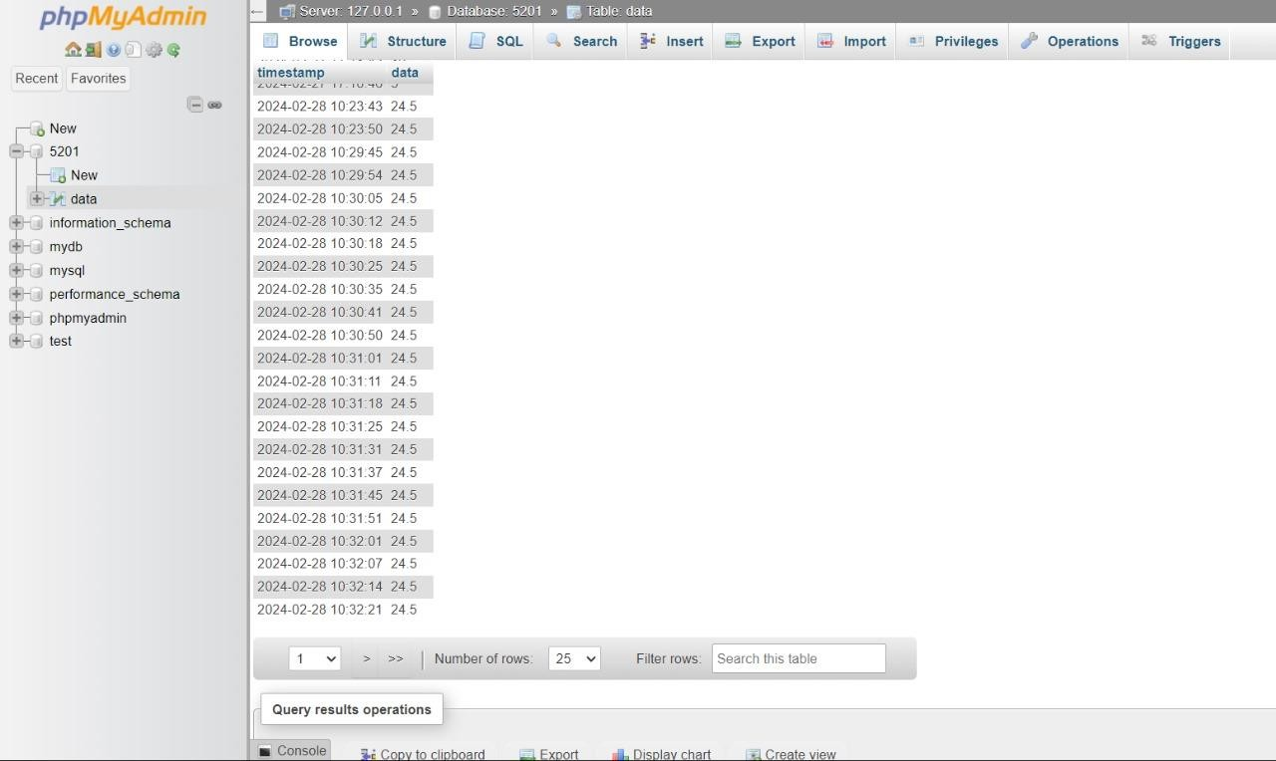
Conclusion:
Hence we demonstrated to store temperature data through M5 Stack Into MySQL database.

Experiment – 9

Connecting device to AWS IoT
Aim: To connect a device using python to AWS IoT.

Apparatus:
- AWS IoT Core.
- Git
- Python 3

Procedure:
- Go to AWS IoT Core and Connect one device option.
- Prepare your device.
- Create a thing and attach a policy to it'
- Take the certificate which is generated automatically.
- Choose OS platform and SDK for device.
- Download the connection kit and extract them.
- Run the commands in PowerShell.
- The connection kit has sample code.
- Run the code in 'start' program in power shell.
- Observe the output in MQTT test client by subscribing to same topic.

Output:
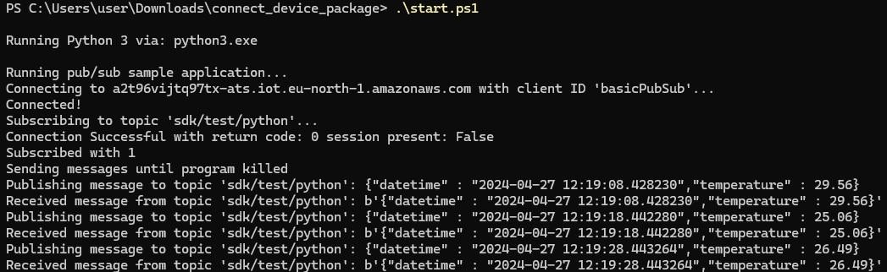

Conclusion:
Hence, we connected device to AWS IoT

Experiment – 10

Connecting M5 stack to AWS (Secure)
Aim: To connect M5 stack to AWS through secure connection

Apparatus:
- AWS IoT
- M5 Stack Board
- Arduino

Algorithm:
- Include all the necessary header file in the program.
- Define the publish and subscribe topic for the MQTT.
- Connect to Wi-Fi using the credentials and print the status of connection.
- Configure WiFi Client Secure to use the AWS IoT device credentials.
- Connect to the MQTT broker on the AWS endpoint we defined earlier.
- Create a message handler.
- If client connection failed, print the failed reason.
- Subscribe to a topic.
- Publish the message using a buffer in which data is stored.
- In the setup, connect to AWS.
- In the loop, publish the message in which message handler will subscribe to the topic.

Procedure:
- Sign in to AWS Console and choose go to things.
- Create a thing and attach a policy to it.
- Download the certificates given for the thing.
- Open the Arduino and type the program.
- In the ‘secrets.h’ file, paste the certificates given by AWS.
- Dump the code into M5 Stack board.
- Observe the published message in the MQTT test client of AWS.

Code:

#include "secrets.h"
#include <WiFiClientSecure.h> #include <MQTTClient.h> #include "ArduinoJson.h" #include "WiFi.h"

// The MQTT topics that this device should publish/subscribe #define AWS_IOT_PUBLISH_TOPIC "sdk/test/python"
#define AWS_IOT_SUBSCRIBE_TOPIC "sdk/test/python"

WiFiClientSecure net = WiFiClientSecure(); MQTTClient client = MQTTClient(256);

void connectAWS()
{
WiFi.mode(WIFI_STA); WiFi.begin(WIFI_SSID, WIFI_PASSWORD);
Serial.println("Connecting to Wi-Fi"); while (WiFi.status() != WL_CONNECTED){
delay(500);
Serial.print(".");
}

// Configure WiFiClientSecure to use the AWS IoT device credentials net.setCACert(AWS_CERT_CA);
net.setCertificate(AWS_CERT_CRT); net.setPrivateKey(AWS_CERT_PRIVATE);

// Connect to the MQTT broker on the AWS endpoint we defined earlier client.begin(AWS_IOT_ENDPOINT, 8883, net);

// Create a message handler client.onMessage(messageHandler);

for (int i =0;AWS_CERT_CA[i] != 0; i++) Serial.print(AWS_CERT_CA[i]);
Serial.print("Connecting to AWS IOT");

while (!client.connect(THINGNAME)) { Serial.print("failed, reason -> ");
Serial.print("."); delay(100);
}

if(!client.connected()){ Serial.println("AWS IoT Timeout!"); return;
}

// Subscribe to a topic client.subscribe(AWS_IOT_SUBSCRIBE_TOPIC);

Serial.println("AWS IoT Connected!");
}

void publishMessage()
{
StaticJsonDocument<200> doc; doc["time"] = millis(); doc["sensor_a0"] = analogRead(0); char jsonBuffer[512];

serializeJson(doc, jsonBuffer); // print to client

client.publish(AWS_IOT_PUBLISH_TOPIC, jsonBuffer);
}

void messageHandler(String &topic, String &payload) { Serial.println("incoming: " + topic + " - " + payload);

// StaticJsonDocument<200> doc;
// deserializeJson(doc, payload);
// const char* message = doc["message"];
}

void setup() { Serial.begin(115200); connectAWS();
}

void loop() { publishMessage(); client.loop(); delay(1000);
}

Output:
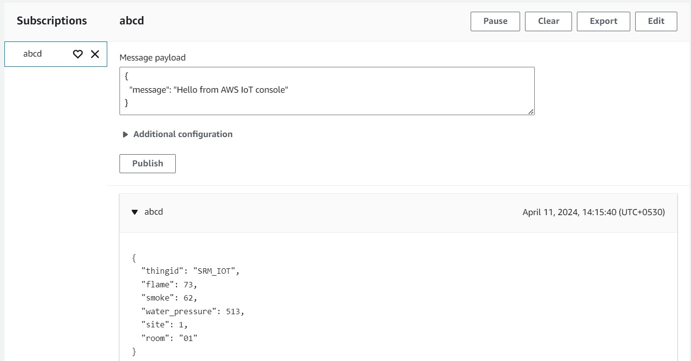

Conclusion: Hence, we connected a device to AWS through secure connection.

Experiment – 11

Simple Notification Service - Aws IoT

Aim: To get message to email through SNS in AWS IoT.

Apparatus:
- AWS IoT Core-SNS
- Git
- Python 3.

Procedure:

  - Run the connection kit in PowerShell.
  - Create a rule.
  - Attach a policy to it.
  - Assign the role as SNS.
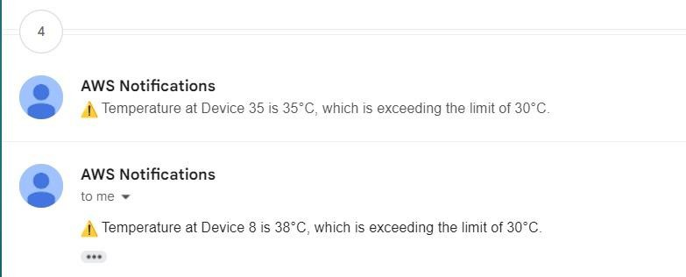
  - Give mail ID to the rule, select all from the given topic through SSL.
  - Activate the rule.
  - View the messages in the given mail ID.
  - Deactivate the rule.

Output:

Conclusion: Hence we used SNS in AWS IoT Core.

Experiment – 12

DynamoDB - AWS IoT
Aim: To store the data in DynamoDB in Aws IoT. Apparatus:
- Aws IoT-DynamoDB
- Git
- Python 3

Procedure:

- Run the connection kit in PowerShell.
- Create a rule.
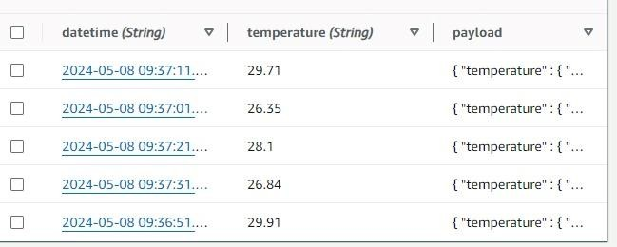
- Attach the policy to the rule.
- Assign the role as DynamoDB.
- Give the SQL statement to select all from the topic.
- Give the table name and Keys with data type that is to be inserted into it.
- Run the program and check the data inserted in table in DynamoDB.
- Deactivate the rule.

Output:

Conclusion: Hence, we stored data in DynamoDB by running python program

Experiment – 13

AWS Lambda

Aim:
To implement Aws Lambda and observe the CloudWatch logs.

Apparatus:
1) AWS IoT-Lambda

Procedure:
- Open Lambda in Aws.
- Create a Lambda function.
- Create a role for the Lambda function
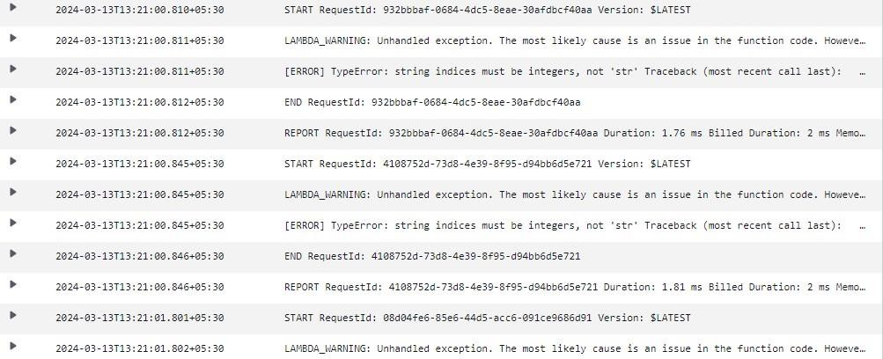
- In the Lambda function, write the necessary code to take the data.
- Add Aws IoT trigger for the Lambda Function.
- Run the Lambda function.
- Watch the output in the Cloud Watch logs in the AWS IoT Trigger.
- Deactivate the role.
Output:

Conclusion: Hence, we implemented Lambda function in AWS.

Experiment – 14

CoAP CLIENT AND SERVER

Aim: To implement CoAP client and Server in M5 Stack using Arduino.

Apparatus:
- M5 Stack board
- Arduino

Algorithm:

CoAP Client:

- Install all libraries
- Give Wi-Fi SSID, Wi-Fi Password and Server IP, server port.
- In the setup, connect Wi-Fi, and print the status.
- In the loop, if Button is pressed, send the button name to the server.
- In the message ID send the message of Button using server port and server IP.
- Print the details in the display.

CoAP Server-
  - Install the libraries.
  - Give the Wi-Fi SSID and password.
  - In the CoAP function, take the packet with the IP address & port number.
  - Copy the packet with payload and take the message.
  - Compare the given message to print the respective alphabet.
  - In the setup, connect the with using Wi-Fi begin.
  - Print the IP address of it.
  - Start the CoAP function to receive and print the data.
  - In the loop function, give delay and start coap.loop().

Procedure:
- Write code for the server M5Stack to handle CoAP requests.
- Connect the server M5Stack to a WiFi network and obtain its IP address.
- Upload the server code to the M5Stack.
- Write code for the client M5Stack to send CoAP requests.
- Specify the IP address of the server in the client code.
- Upload the client code to the M5Stack.
- When a button is pressed on the client M5Stack, it sends a request to the server M5Stack.
- The server M5Stack receives the request and prints a message indicating the button press.
- Ensure both M5Stacks are connected to the same WiFi network.
- Test the communication by pressing buttons on the client M5Stack and observing the printed messages on the server M5Stack's display.

Code:

Server –
#include <WiFi.h> #include <WiFiUdp.h> #include <coap-simple.h> #include <M5Stack.h> #include "driver/ledc.h"

const int servo_pin = 15; int freq = 50;
int ledChannel = 0; int resolution = 8;

const char* ssid = "Na wifi";
const char* password = "sarala999";

WiFiUDP udp;
Coap coap(udp);

void callback_button(CoapPacket &packet, IPAddress ip, int port) { char p[packet.payloadlen + 1];
memcpy(p, packet.payload, packet.payloadlen); p[packet.payloadlen] = NULL;

String message(p);

if (message.equals("A")) { M5.Lcd.print("A is pressed"); ledcWrite(ledChannel, 6);//0° delay(1000);
} else if (message.equals("B")) { M5.Lcd.print("B is pressed"); ledcWrite(ledChannel, 18);//90° delay(1000);
} else if (message.equals("C")) { M5.Lcd.print("C is pressed"); ledcWrite(ledChannel, 30);//180° delay(1000);
}
}

void setup() { M5.begin();

ledcSetup(ledChannel, freq, resolution); ledcAttachPin(servo_pin, ledChannel);

M5.Lcd.fillScreen(BLACK); M5.Lcd.setTextColor(WHITE);

WiFi.begin(ssid, password);
while (WiFi.status() != WL_CONNECTED) { delay(500);
M5.Lcd.print(".");
}

M5.Lcd.println(""); M5.Lcd.println("WiFi connected"); M5.Lcd.println("IP address:"); M5.Lcd.println(WiFi.localIP());

coap.server(callback_button, "button"); coap.start();
}

void loop() { delay(500); coap.loop();
}

Client

#include <M5Stack.h> #include <WiFi.h> #include <WiFiUdp.h> #include <coap-simple.h>

const char* ssid = "Na wifi";
const char* password = "sarala999";
IPAddress serverIP(192, 168, 6, 105); // Update with your server's IP address int serverPort = 5683; // CoAP default port

WiFiUDP udp;
Coap coap(udp);

void setup() { M5.begin();

M5.Lcd.fillScreen(BLACK); M5.Lcd.setTextColor(WHITE);
WiFi.begin(ssid, password);
while (WiFi.status() != WL_CONNECTED) { delay(500);
M5.Lcd.print(".");
}

M5.Lcd.println(""); M5.Lcd.println("WiFi connected"); M5.Lcd.println("IP address:"); M5.Lcd.println(WiFi.localIP());

coap.start();
}

void loop() { M5.update();

if (M5.BtnA.wasReleased()) { sendButtonState("A");
} else if (M5.BtnB.wasReleased()) { sendButtonState("B");
} else if (M5.BtnC.wasReleased()) { sendButtonState("C");
}

delay(100);
}
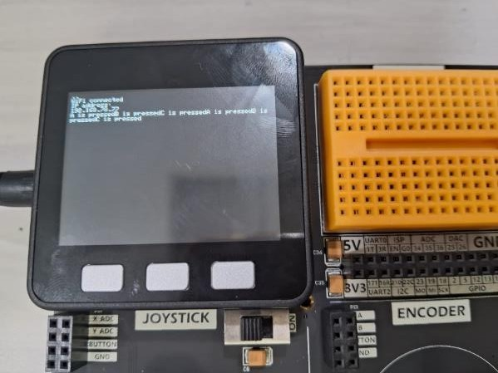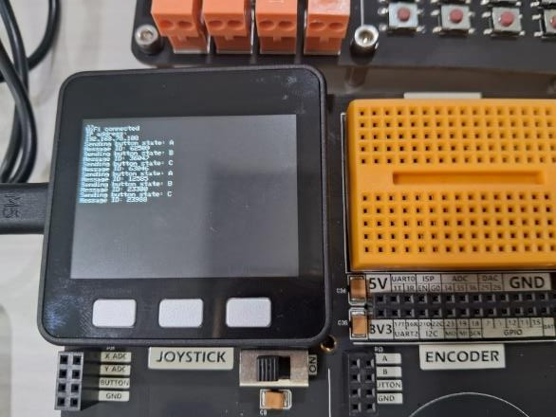
void sendButtonState(const char* button) { M5.Lcd.print("Sending button state: "); M5.Lcd.println(button);

int msgid = coap.put(serverIP, serverPort, "button", button); M5.Lcd.print("Message ID: ");
M5.Lcd.println(msgid);
}

Outputs:

Conclusion: Hence, implemented that Coap client and server using M5 Stack board.

Experiment – 15

UDP Server - Client Communication
Aim: To demonstrate UDP Server - Client Communication

Apparatus:
Linux terminal

Algorithm:
UDP Server:
- Create a UDP socket.
- Bind the socket to the server address.
- Wait until the datagram packet arrives from the client.
- Process the datagram packet and send a reply to the client.
- Go back to Step 3. UDP Client:
- Create a UDP socket.
- Send a message to the server.
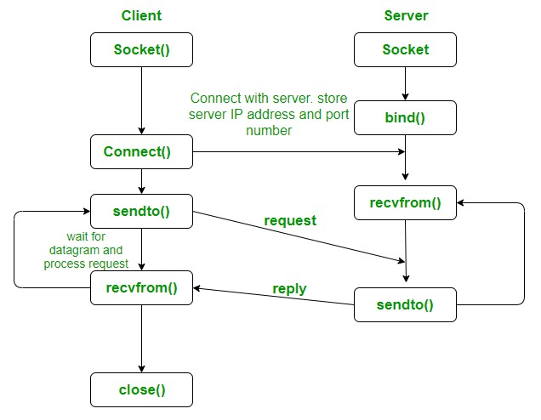
- Wait until response from the server is received.
- Process reply and go back to step 2, if necessary.
- Close socket descriptor and exit.

Flow chart:

Procedure:
- Open Linux terminal
- Install GCC compiler
- Compile client and server files.
- Run the server in one terminal.
- Run client in another terminal
- Communicate between client and Server..
- Disconnect the connection.
UDP Server:
#include <stdio.h> #include <stdlib.h> #include <unistd.h> #include <string.h> #include <sys/types.h> #include <sys/socket.h> #include <arpa/inet.h> #include <netinet/in.h>

#define PORT 8080
#define MAXLINE 1024

// Driver code int main() {
int sockfd;
char buffer[MAXLINE];
char hello[] = "Hello from server"; struct sockaddr_in servaddr, cliaddr;

// Creating socket file descriptor
if ( (sockfd = socket(AF_INET, SOCK_DGRAM, 0)) < 0 ) {
// This print the string along with the description of error for the particular error number.
perror("socket creation failed"); exit(EXIT_FAILURE);
}

memset(&servaddr, 0, sizeof(servaddr));
memset(&cliaddr, 0, sizeof(cliaddr));

// Filling server information servaddr.sin_family = AF_INET; // IPv4 servaddr.sin_addr.s_addr = INADDR_ANY; servaddr.sin_port = htons(PORT);

// Bind the socket with the server address
if ( bind(sockfd, (const struct sockaddr *)&servaddr, sizeof(servaddr)) < 0 )
{
perror("bind failed"); exit(EXIT_FAILURE);
}

int len, n;

len = sizeof(cliaddr); //len is value/resuslt n = recvfrom(sockfd, (char *)buffer, MAXLINE,
0, ( struct sockaddr *) &cliaddr, &len);
buffer[n] = '\0'; printf("Client : %s\n", buffer); printf("Enter the message\n"); scanf("%s", hello);
printf("The message is %s", hello); sendto(sockfd, (const char *)hello, strlen(hello),
0, (const struct sockaddr *) &cliaddr, len);
printf("Hello message sent.\n"); return 0;
}
UDP Client:
#include <stdio.h> #include <stdlib.h> #include <unistd.h> #include <string.h> #include <sys/types.h> #include <sys/socket.h> #include <arpa/inet.h> #include <netinet/in.h>

#define PORT 8080
#define MAXLINE 1024

// Driver code int main() {
int sockfd;
char buffer[MAXLINE];
char hello[] = "Hello from client"; struct sockaddr_in servaddr;

// Creating socket file descriptor
if ( (sockfd = socket(AF_INET, SOCK_DGRAM, 0)) < 0 ) { perror("socket creation failed"); exit(EXIT_FAILURE);
}
memset(&servaddr, 0, sizeof(servaddr));
// Filling server information servaddr.sin_family = AF_INET; servaddr.sin_port = htons(PORT); servaddr.sin_addr.s_addr = INADDR_ANY;

int n, len;
printf("Enter the message\n"); scanf("%s", hello);
printf("The message is %s", hello); getchar();

sendto(sockfd, (const char *)hello, strlen(hello), 0, (const struct sockaddr *) &servaddr,
sizeof(servaddr)); printf("message sent.\n");

n = recvfrom(sockfd, (char *)buffer, MAXLINE,
0, (struct sockaddr *) &servaddr, &len);
buffer[n] = '\0'; printf("Server : %s\n", buffer);

close(sockfd); return 0;}

Output:
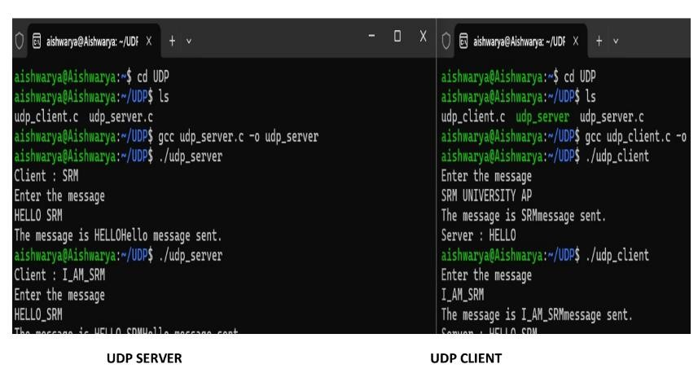

Conclusion: Here we obtained the communication for UDP Server to Multi Client communication Program.

